INFO531/ISTA431: Data Warehousing and Analytics in the Cloud
Week 14 Assignment
Topic: Logistic Regression (Supervised Learning)
Assignment Instructions: In your submission provide information in this order: Each Question, input data (if any), Code, and Results in a Word document or PDF file. Grade points: 100 (10 points for each question).

1. Download this weather data file (weatherAUS.csv) from the Kaggle site. This dataset contains about 10 years of daily weather observations from numerous Australian weather stations.
https://www.kaggle.com/prashant111/logistic-regression-classifier-tutorial/data
Then (1) create a DataFrame in Python using Pandas, (2) Read the data into a data frame, (3) Display the number of rows and columns in the data file, and the first five lines of the data file, including the variable names, and (4) Display the data type for each variable.
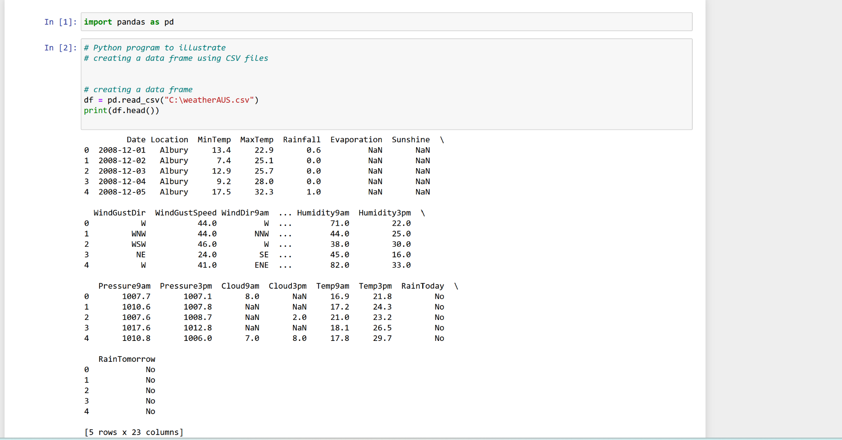
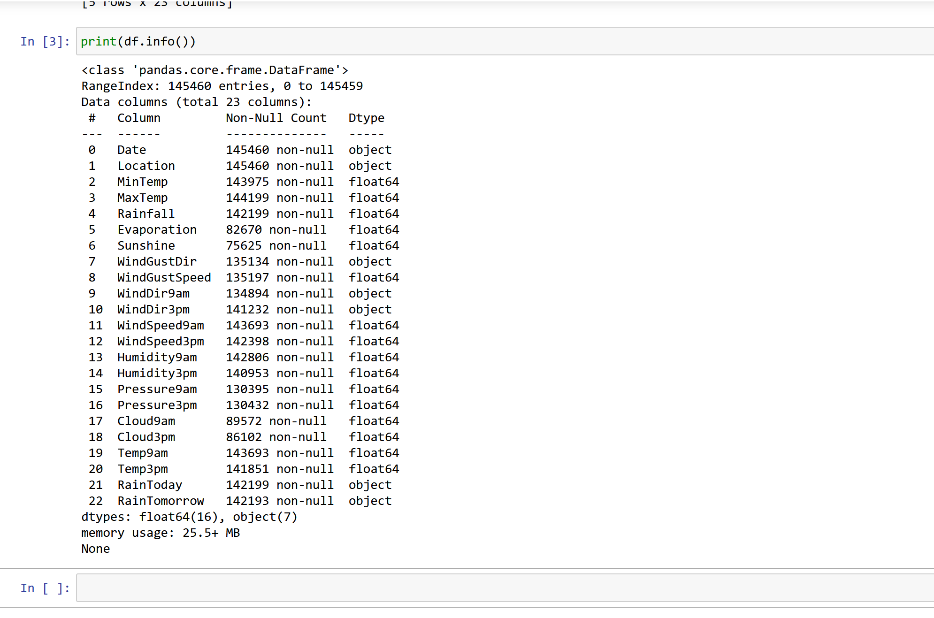
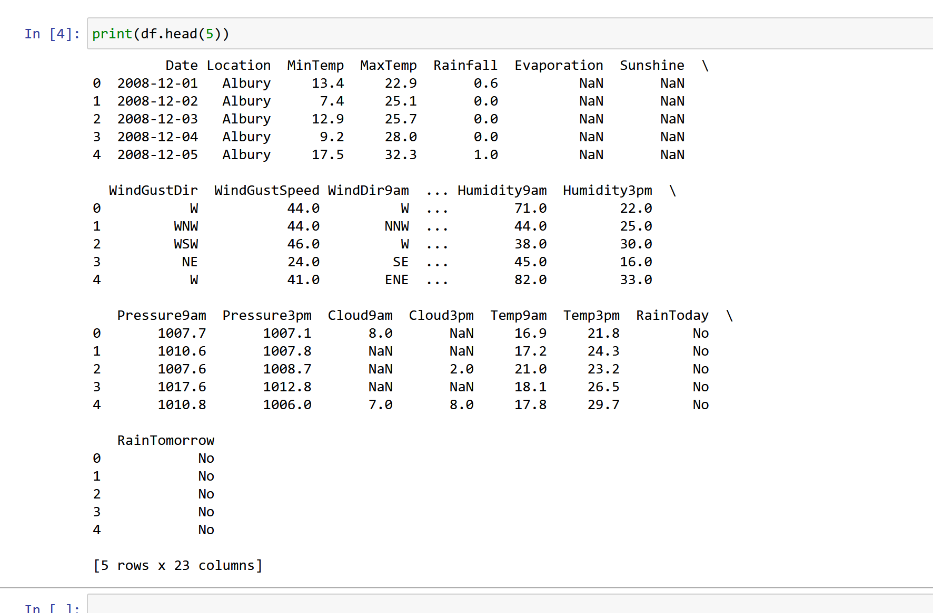

2. Pre-Process Data: (1) Drop the following variables: MinTemp, MaxTemp, Rainfall, Evaporation, Sunshine, WindGustDir, WindGustSpeed, WindDir9am, WindDir3pm, Pressure9am, Pressure3pm, Cloud9am, Cloud3pm, RainToday. (2) Next, display the number of rows and columns in the data file, and the first five lines of the data file, including the variable names, and (3) Next, display the data type for each variable.
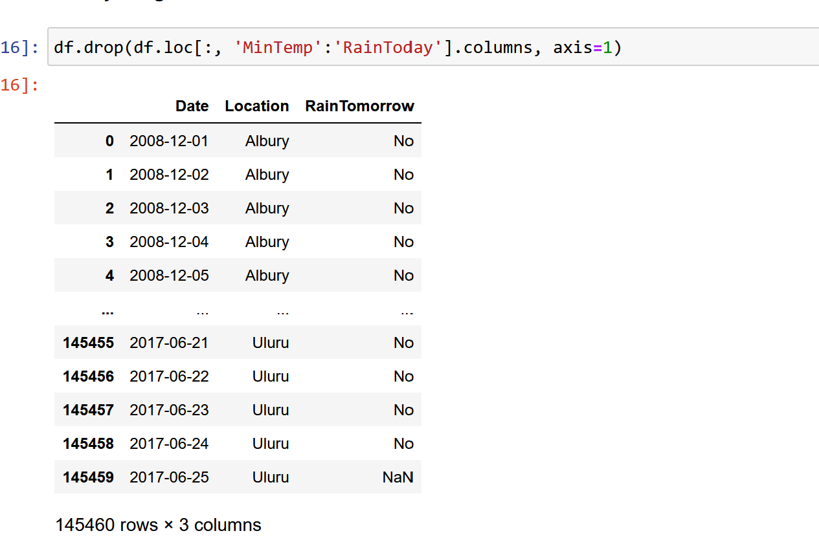
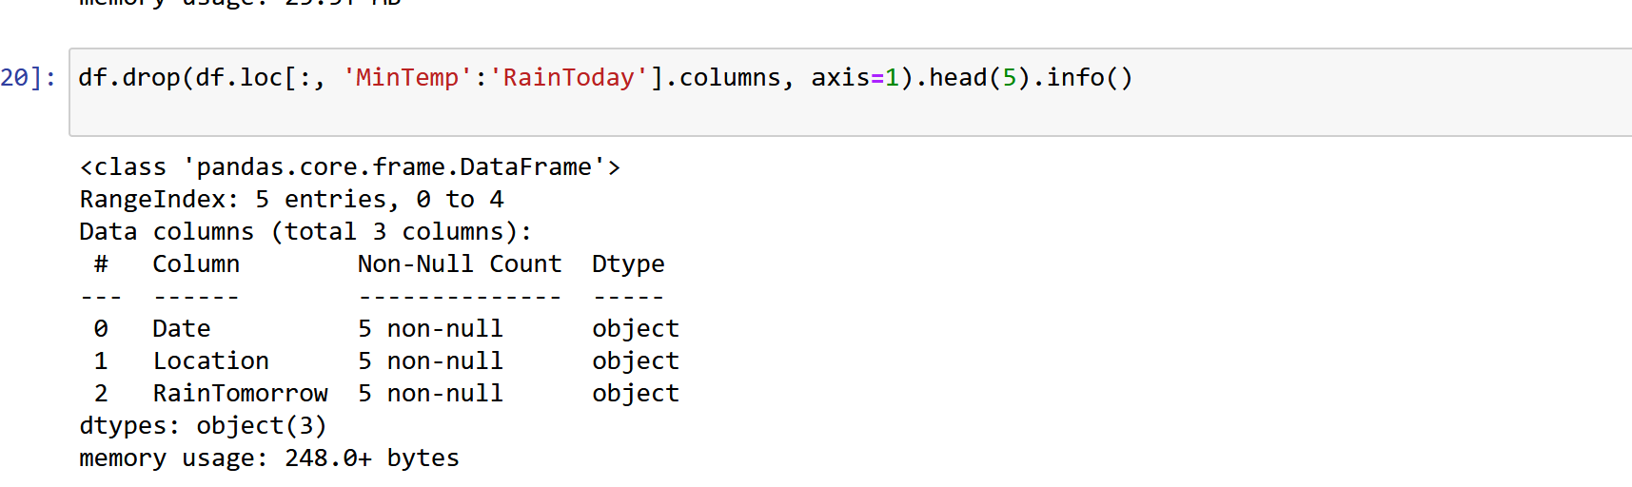

3. As part of Data Exploration and Data Engineering, Check for missing values and fix the missing value issues. [Note: With this set of data, change the variable values from 'NA' to NULL (Use np.nan to conver to null; Hints: use numpy library), that is, all non-numeric values need to be changed to null.] Next, drop all rows that contain column values null. Hints: Use dropna() function to do that.
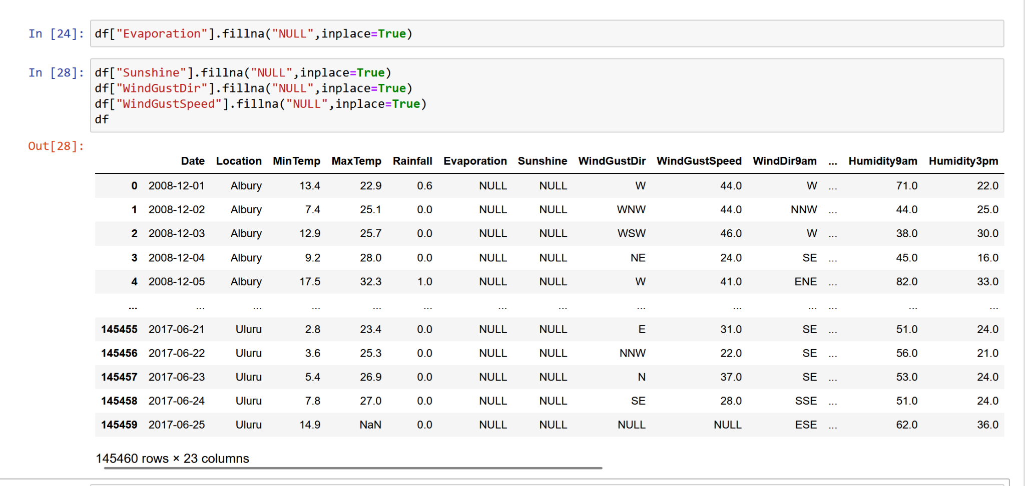
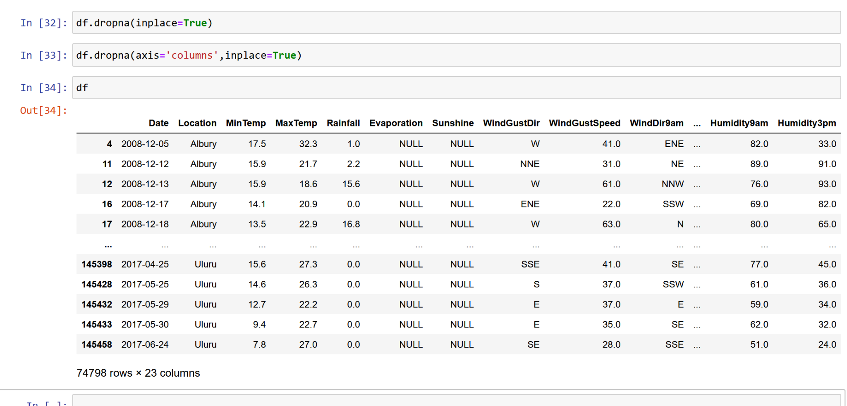

4. Data Preparation: Split dataset in two parts: feature set and target label:
feature_set = ['WindSpeed9am', 'WindSpeed3pm', 'Humidity9am', 'Humidity3pm', 'Temp9am', 'Temp3pm']
target_set: 'RainTomorrow'. Convert target variable, RainTomorrow, values from ‘Yes’ to 1 and ‘No’ to 0 (zero).
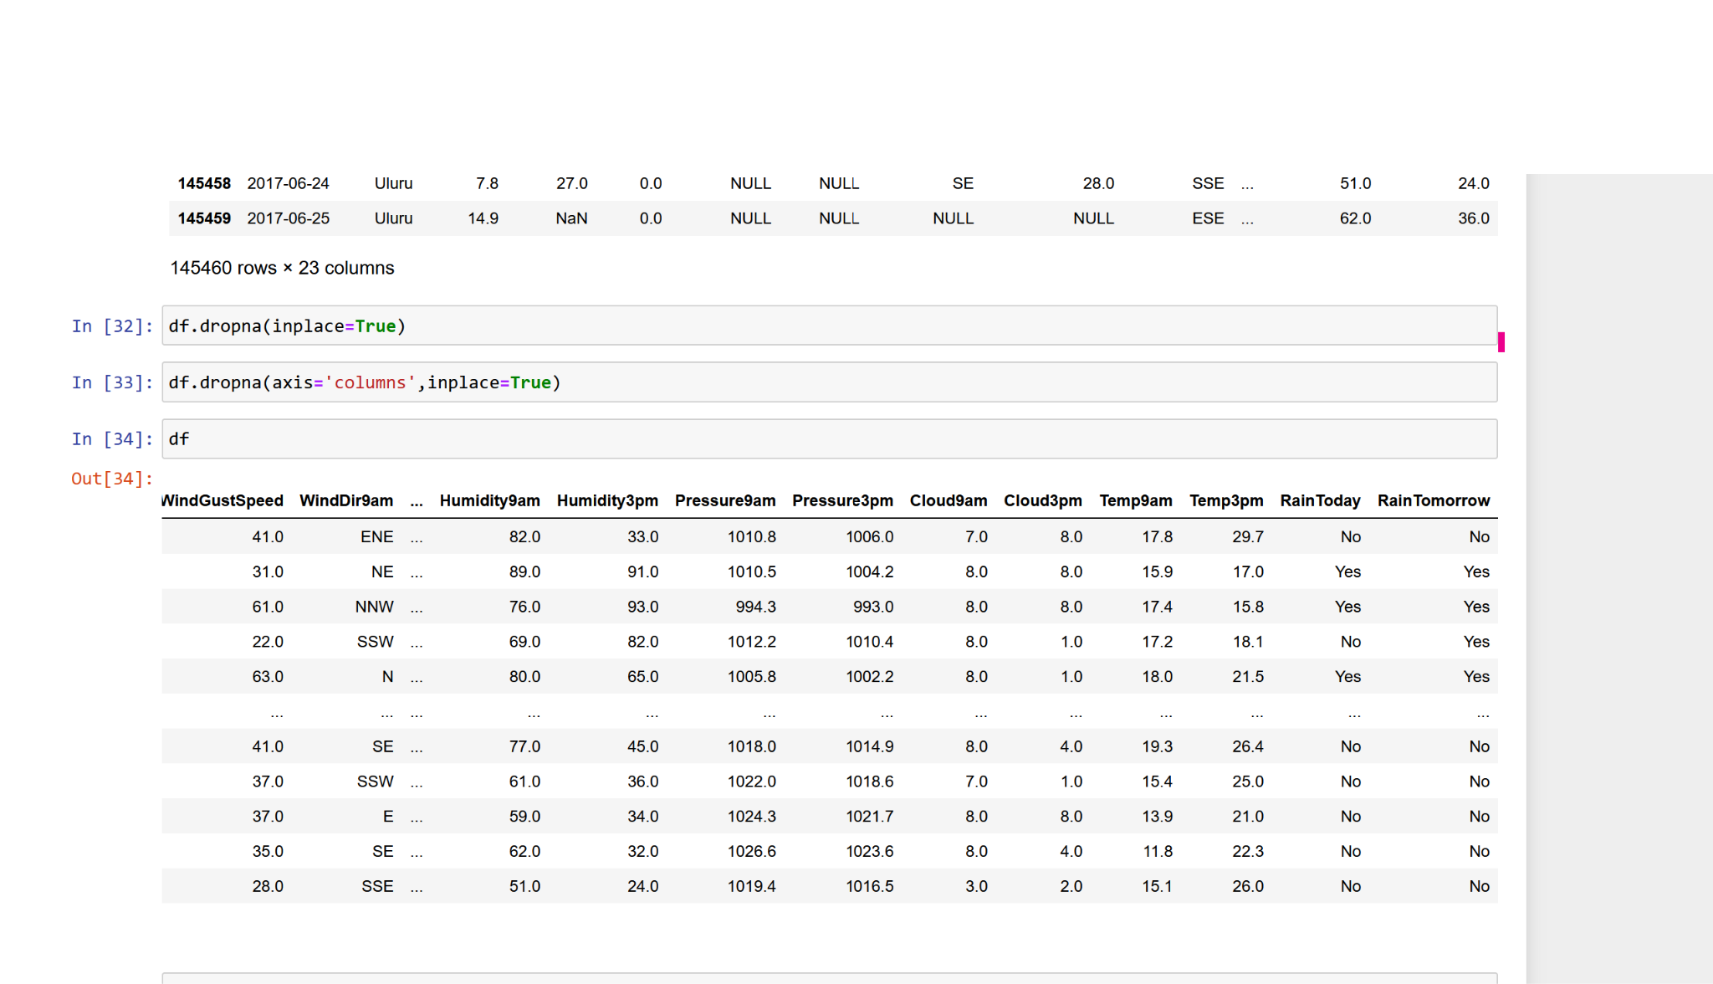

5. Do a pairplot of data using seaborn (import seaborn library). Show the plots for each of the Features along with target variable (RainTomorrow).
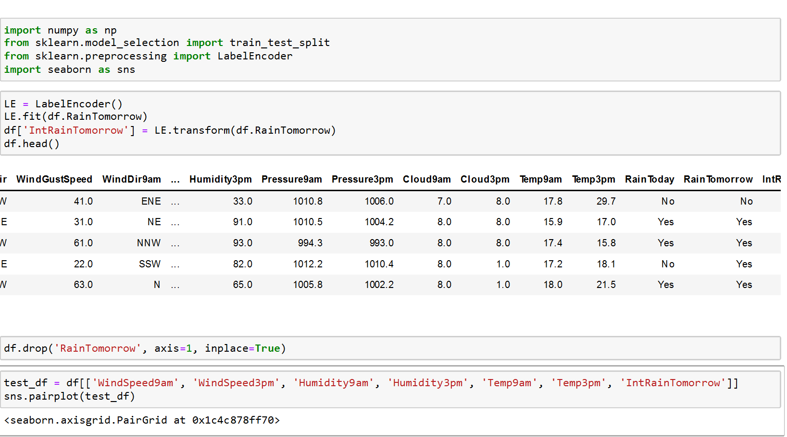

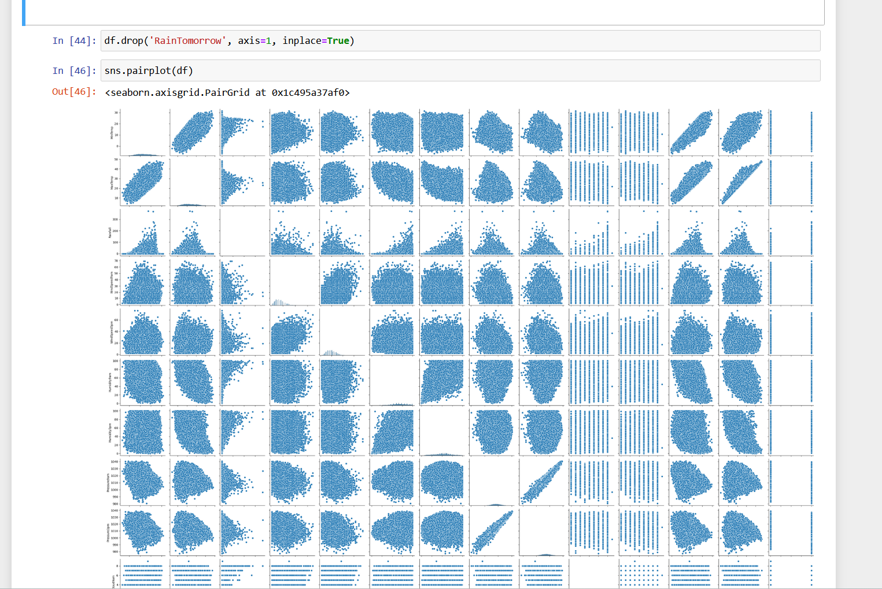

6. Import train_test_split function from sklearn library. Split X and y into feature_train, feature_test, target_train, target_test.
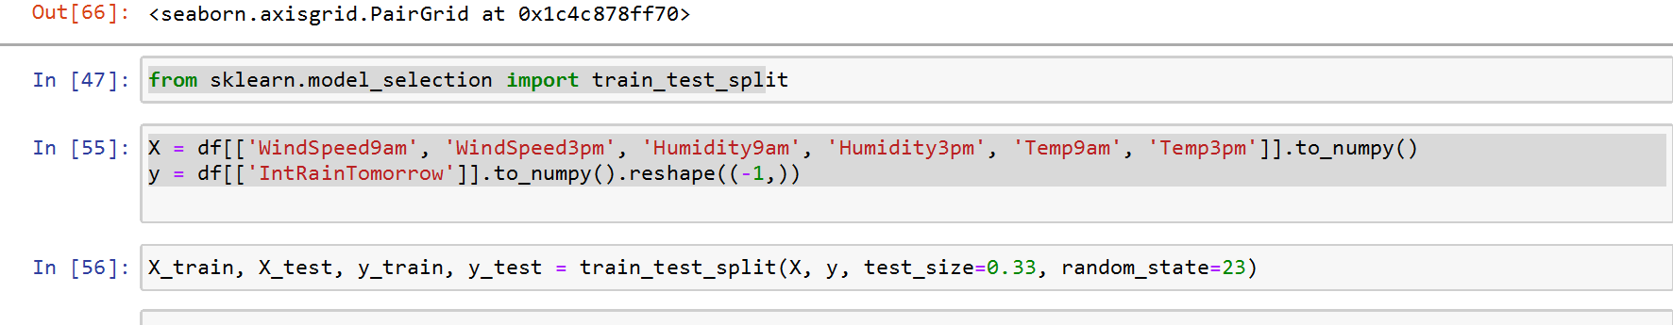

7. Import logistic regression scikit-learn model: From sklearn.linear_model import LogisticRegression; and from sklearn.metrics import accuracy_score (for performance evaluation).
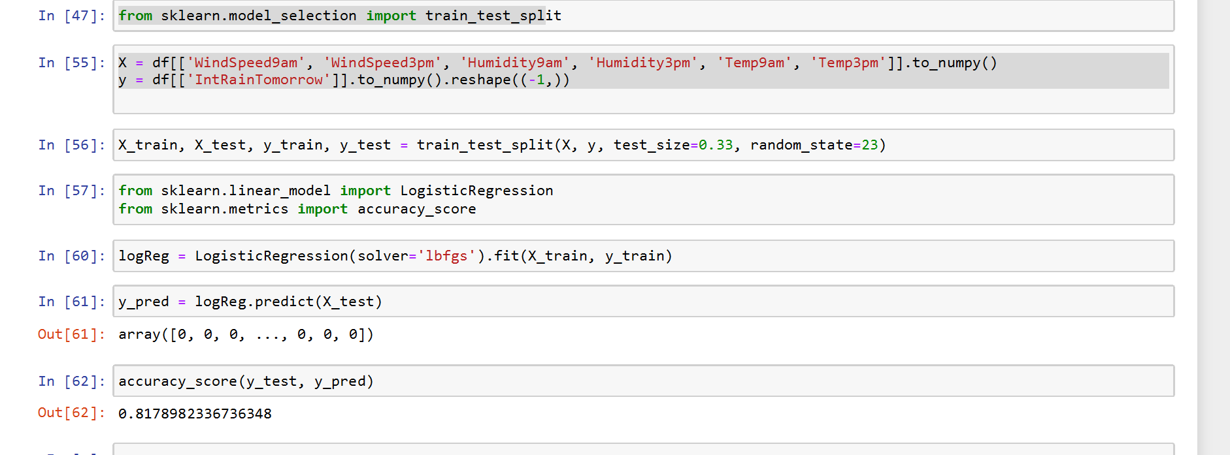
8. Instantiate the model [Hints: logreg = LogisticRegression(solver='lbfgs')]. Then, fit the model with data [Hints: logreg.fit(feature_train,target_train)]

9. Forecast the target variable for given test dataset [Hints: predictions = logreg.predict(feature_test)]. Assess model performance using accuracy measure [Hints: print("Logistic Regression Model Accuracy:",accuracy_score(target_test, predictions))]. Interpret the result.
From the score, it is understood that my model is 81%accurate.


10. Provide each question followed by code, followed by results (readable screenshots) in a single Word document or PDF file. Name your file according to this convention: INFO531/ISTA431_Week14_Lastname.pdf. Submit your completed assignment to the Week 14 Dropbox by the deadline.
END
2

